**Trabajo Práctico 8 - Sistemas Operativos**

**Integrantes:**

* Borgogno, Francisco
* Cañas, Felipe
* Lucero Ruiz, Maximo
* Quesada, Santiago

**Profesor:** Funes, Gustavo

**1.**

| **cut -d: -f1 /etc/passwd > linux-users.txt cut -d: -f1 /etc/group > linux-groups.txt** |
| --- |



**2.**

| **diff linux-users.txt /etc/passwd** |
| --- |

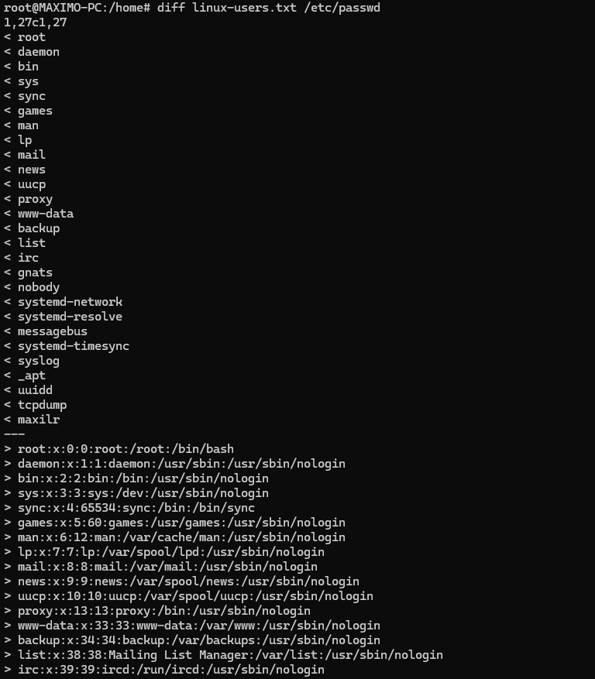

| **diff linux-groups.txt /etc/group** |
| --- |

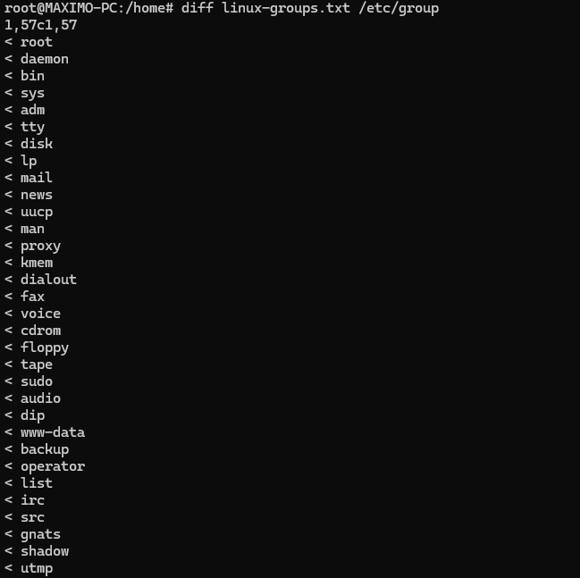

**3.**

| **echo -e “useradd\nusermod\nuserdel\ngroupadd\ngroupmod\ngroupdel\nchmod\nchown\nchgrp" > ~/comandos-03.txt** |
| --- |



**4.**

| **sudo mv comandos-03.txt /etc/skel/** |
| --- |



**5.**

| **sudo useradd -c "John Doe" -m jd** |
| --- |



| **echo jd:j1d3 | sudo chpasswd** |
| --- |



**6.**

| **sudo groupadd students** |
| --- |



**7.**

| **id** |
| --- |



| **grep "$USER" /etc/passwd** |
| --- |



| **sudo usermod -c "Maximo Lucero Ruiz" $USER** |
| --- |





**8.**

| **sudo usermod -aG students $USER** |
| --- |



| **sudo usermod -aG students jd** |
| --- |



**9.**

| **sudo usermod -u 1111 jd** |
| --- |





**10.**

| **sudo usermod -s /bin/bash maxilr** |
| --- |



| **sudo usermod -s /bin/bash jd** |
| --- |



**11.**

| **whoami** |
| --- |



| **su - jd** |
| --- |

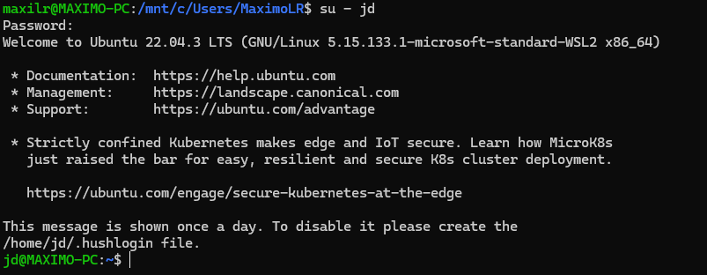

**12.**

| **ls -l /home/** |
| --- |

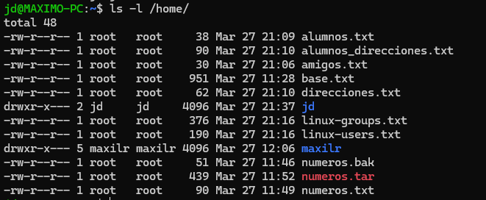

| **ls /etc/skel/** |
| --- |

